

Project Review 1&2
DEPARTMENT OF ARTIFICIAL INTELLIGENCE AND MACHINE LEARNING
PROJECT TITLE : COLLEGE EVENT MANAGEMENT SYSTEM

Guide:- T.Vijayalakshmi Assistant Professor Department Of AIML
B.LASYA SHARON | 25B11AI098 | AIML
ANANYA DAS | 25B11AI037 | AIML
SANANDA CHOWDHURY MEDHA | 25B11AIA67 | AIML
K.KURMANADH | 25B11AI614 | AIML

Team Members : Registration Number: Branch:


Outline:
- Project Title & Team Members
- Project Objective
- Problem Statement
- System Modules
- Class Structure & OOP Concepts
- Event Registration & Attendance
- Venue Allocation
- Core Functions & STL Vector
- File Handling & Data Persistence
- Input Validation
- Testing & Validation
- Application Output
- Team Member Contributions
- Future Enhancements
- Conclusion


ABSTRACT:

  - The College Event Management System is a C++ application designed to manage common college-event activities in a structured way. It maintains student, coordinator, venue and event information, supports event registration, venue allocation and attendance marking, and generates an event-wise report.
  - The project applies Object-Oriented Programming concepts such as classes, inheritance, abstraction, encapsulation and polymorphism. STL vectors are used to store dynamic collections, while file handling is used to save and reload data between program runs.

INTRODUCTION:

- College events involve multiple activities such as creating events, assigning coordinators and venues, registering students and tracking attendance. Managing these activities manually can make information difficult to organize and retrieve.
- This project provides a simple console-based system that brings these operations together in one application and demonstrates how C++ OOP can model a real-world event-management workflow.

PROBLEM STATEMENT:

  - Create a single system to manage college students, coordinators, venues and events.
  - Allow students to register for available events without duplicate registration.
  - Assign available venues to events and prevent reuse of an already allocated venue.
  - Record attendance only for registered students.
  - Generate event-wise reports showing registration and attendance status.
  - Store data in files so records can be loaded again when the program starts.


OBJECTIVES:

- To develop a College Event Management System using C++.
- To apply OOP concepts such as inheritance, abstraction, encapsulation and polymorphism.
- To manage students, coordinators, venues and events using classes.
- To provide event registration and attendance tracking.
- To allocate venues while checking availability.
- To generate useful event reports.
- To save and load system data using file handling.

SYSTEM MODULES

Module | Purpose
Student Management | Add and display students; store registered event IDs.
Coordinator Management | Add and display event coordinators.
Venue Management | Create venues, show capacity and allocation status.
Event Management | Create and display events with date, coordinator and capacity.
Venue Allocation | Assign an available venue to a selected event.
Event Registration | Register a student and prevent duplicate/full registrations.
Attendance | Mark registered students as present.
Event Report | Display registered students with Present/Absent status.
File Storage | Save and reload students, coordinators, venues and events.

CLASS STRUCTURE

Person – abstract base class containing common ID and name data. Student : public Person – stores department and registered event IDs. Coordinator : public Person – stores department information.
Venue – stores venue ID, name, capacity and allocation status.
Event – stores event details, venue, registered students and attendance.
EventManagementSystem – manages collections and performs the main operations.


C++ CONCEPTS USED

Concept | Where Used | Purpose
Classes & Objects | Person, Student, Coordinator, Venue, Event | Model real-world entities
Inheritance | Student/Coordinator inherit Person | Reuse common attributes
Abstraction | Person has pure virtual display() | Define common interface
Polymorphism | virtual display() | Different display behavior
Encapsulation | Private class data + methods | Protect and organize data
Constructors | All major classes | Initialize objects
STL vector | Students, events, venues, IDs | Dynamic collections
Algorithms | find() | Search and duplicate checking



ATTENDANCE & EVENT REPORT

- Attendance can be marked only for a student who is registered for the event.
- bool present = find(pres.begin(), pres.end(), reg[i])
!= pres.end();
cout << students[j].getId() << " "
<< students[j].getName() << " - "
<< (present ? "Present" : "Absent");
- The system prevents the same student from being marked present twice.
- Event reports display the event name, date, coordinator and registration count.
- Each registered student is shown
with Present or Absent status.


VENUE ALLOCATION

- Display available events and

if (v->isAllocated()) { cout << "Venue already
allocated.\n"; return;
}
v->allocate();
e->setVenueId(vid);
venues.
- Accept an Event ID and Venue ID.
- Check whether both records exist.
- Check whether the selected venue
is already allocated.
- Allocate the venue and store its ID inside the event.
- If any condition fails, the system
displays an appropriate message.


CORE FUNCTIONS

Function | Role
addStudent() | Creates a student record and assigns an ID.
addCoordinator() | Creates a coordinator record.
addVenue() | Creates a venue with capacity.
addEvent() | Creates an event with date, coordinator and participant limit.
allocateVenueToEvent() | Assigns an available venue to an event.
registerStudentForEvent() | Validates and registers a student.
markAttendance() | Marks a registered student present.
generateEventReport() | Displays event registration and attendance.
saveData() / loadData() | Persist and restore application data.

STL VECTOR & REGISTRATION

vector<Student> students; vector<Event> events;
bool addRegistration(int sid) {
if ((int)registeredStudents.size()
>= maxParticipants)
return false;
if (find(registeredStudents.begin(),
registeredStudents.end(),
sid)
!= registeredStudents.end()) return false;
registeredStudents.push_back(sid); return true;

The vector stores a dynamic list of objects or student IDs. The find() algorithm is used to check whether a student is already registered before adding a new registration.

}

FILE HANDLING & DATA PERSISTENCE

The system writes records to separate text files: students.txt, coordinators.txt, venues.txt and events.txt. loadData() reads these files when the program starts and reconstructs the stored objects.
ofstream fs("students.txt");
for (size_t i = 0; i < students.size(); i++)
fs << students[i].serialize() << "\n";
ofstream fe("events.txt");
for (size_t i = 0; i < events.size(); i++)
fe << events[i].serialize() << "\n";

DATA SERIALIZATION

Serialization converts an object's important fields into a text format that can be written to a file. splitStr() later separates the stored values and rebuilds the objects.

string serialize() const { stringstream ss;
ss << eventId << "|" << eventName
<< "|"
<< eventDate << "|" << coordinatorName << "|"
<< venueId << "|" << maxParticipants << "|";
...
return ss.str();
}

INPUTS

Operation | Main Input | Example
Add Student | Name, Department | Sananda, AIML
Add Coordinator | Name, Department | Event Coordinator, AIML
Add Venue | Venue Name, Capacity | Seminar Hall, 200
Create Event | Name, Date, Coordinator, Max Participants | Tech Fest, 15-10-2026
Allocate Venue | Event ID, Venue ID | 1, 1
Register Student | Student ID, Event ID | 1, 1
Attendance | Event ID, Student ID | 1, 1
Event Report | Event ID | 1

INPUT VALIDATION & ERROR HANDLING

- Invalid menu input is detected using cin.fail().
- Event and student IDs are checked before operations.
- Duplicate student registration is rejected.
- Registration is rejected when an event reaches maximum capacity.
- Venue allocation is rejected if the venue is already allocated.
- Attendance is rejected when the student is not registered or is
already marked present.
- Malformed file lines are skipped while loading data.

APPLICATION OUTPUT

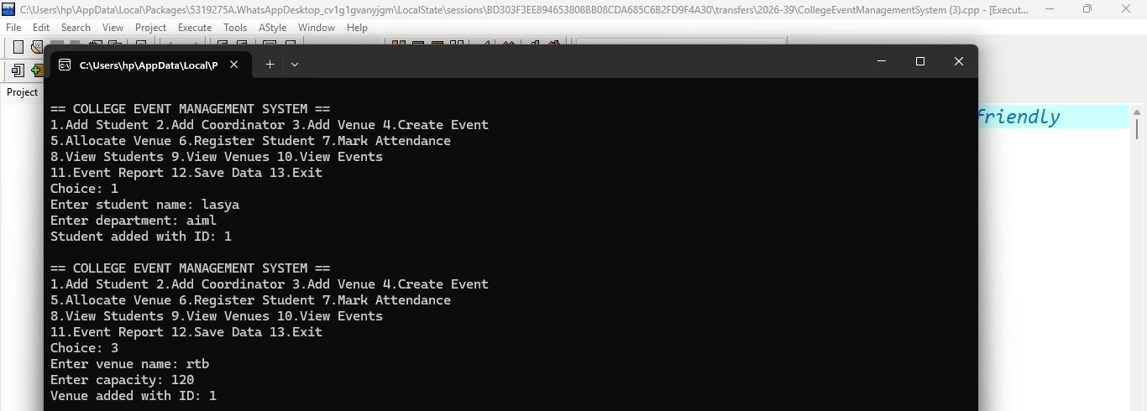


ALGORITHM:

- Start the program and create EventManagementSystem object.
- Load previously saved data from text files.
- Display the main menu.
- Read the user's choice.
- Perform the selected operation: add, allocate, register, attendance, view, report or save.
- Display the result or validation message.
- Repeat the menu until the user selects Exit.
- Save data and stop the program.

TESTING AND VALIDATION

Test | Input / Situation | Expected Result
1 | Create student | Student added with generated ID
2 | Create event | Event created with generated ID
3 | Allocate free venue | Venue allocated to event
4 | Allocate same venue again | Venue already allocated
5 | Register valid student | Registered successfully
6 | Register same student twice | Already registered
7 | Register after capacity | Registration failed: event full
8 | Mark registered student | Attendance marked
9 | Mark unregistered student | Attendance rejected
10 | Restart program | Previously saved records are loaded
11 | Invalid menu input | Invalid input message


APPLICATION MENU

== COLLEGE EVENT MANAGEMENT SYSTEM ==
- Add Student
- Add Coordinator
- Add Venue
- Create Event
- Allocate Venue
- Register Student
- Mark Attendance
- View Students
- View Venues
- View Events
- Event Report
- Save Data
- Exit

TEAM MEMBER CNTRIBUTIONS:

Team Member | Contribution
1. ANANYA DAS | C++ class design and core implementation
2. SANANDA CHOWDHURY MEDHA | Event registration and venue allocation module
3. K.KURMANADH | File handling, serialization and data persistence
4. B.LASYA SHARON | Testing, documentation and presentation

FUTURE ENHANCEMENTS

- Add a graphical user interface for easier interaction.
- Add login and role-based access for students and coordinators.
- Connect the system to a database such as MySQL.
- Add event search, filtering and sorting.
- Add email/SMS notifications for event registration.
- Generate downloadable attendance and event reports.
- Support multiple venues and richer scheduling conflict checks.

CONCLUSION

- The College Event Management System demonstrates how C++ and Object-Oriented Programming can be used to model and manage a real-world college event workflow. The system handles students, coordinators, venues, events, registration and attendance in one application.
- The project also provides practical experience with inheritance, abstraction, polymorphism, encapsulation, STL vectors, algorithms and file handling. It can be extended further with a GUI, database integration, authentication and advanced reporting.

THANK YOU

College Event Management System • C++ / OOP

